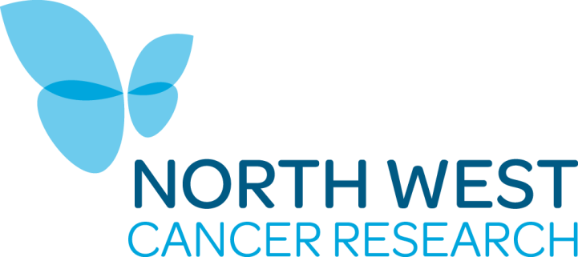

NORTH WEST CANCER RESEARCH GRANT APPLICATION APPLIED RESEARCH CALL: GUIDANCE ON COMPLETING THE APPLICATION FORM

The sections below provide guidance on completing the application form sections.

  - Project Title
The project title should give potential reviewers a clear idea of the proposed research. Any confidential or commercially sensitive information should not be included in the title.

  - Proposed Start Date and Duration
An award should begin as soon as possible and no later than six months after the date of the award letter.

  - Applicant(s)
Only one application will be considered at each submission round for a principle investigator. One additional application will be considered for a researcher named as a principle investigator on another submitted application, when the applicant is a named on a second application as a co-applicant. Applications will be returned if these guidelines are not adhered to.

All applicants named on the grant MUST sign the application form. If signatures are not included, the application form will not be accepted.

Co-investigators should be experienced researchers who have a significant role in the design or management of the project. The roles of each co-investigator must be justified within the application.

  - Scientific Summary of Proposed Research
Please do not include confidential or commercially sensitive information in this summary as it is circulated to potential reviewers. Word limit 250.

5. Lay Summary of Proposed Research
This summary must be suitable for the general public. Do not use technical language. Word limit 250.

6. Communications Plan
Outline your plan to communicate details of your research. This should include potential impacts for academic and non-academic users. Word limit 250.

7. Impact Summary
Outline the potential impact of your work and the steps you will make to achieve these. Please consider the wider definition of impact and how as a charity we measure impact. In your summary please consider how your project would: generate new ideas; translate research in to new ideas and services; create evidence that could influence policy and stakeholders; develop the human capacity to do research; stimulating further research via new funding partnerships. Word limit 250.

8. Previous Submission
If the application is a resubmission to the Charity, please include a covering letter and highlight details of changes from the original application. Please address the concerns raised by both the Applied Research Advisory Group and external reviewers following the original application.

9. Human Subjects
North West Cancer Research expects the research they fund to be conducted to the highest levels of integrity, clarity and good management. Research grants are made between the charity and the research institution, and the charity expects that the researcher and their employers will work within the appropriate legal and ethical boundaries.

10. Use of Animals
North West Cancer Research recommends that researchers follow the guidelines for the welfare and use of animals in research as outlined here. The Charity also promotes the reporting of research using animals according to the ARRIVE (Animal Research: Reporting of In Vivo Experiments) guidelines, as outlined here.

11. Proposed Investigation. This section should not exceed 2,000 words.
The following information should be included:
Background.
Supporting evidence.
Hypothesis and Specific Aims.
Research Plan.
Identified risks and contingencies in place.
References – these can be listed and attached as a separate Appendix.

Tables, images and graphs can be included. These will not be included in the 2,000-word count.

If the project involves patient information, human volunteers or tissue samples, or animals, Appendix A should be completed and submitted with the main application form as part of the submitted PDF document.

12. Independent Referees
Nominated reviewers must be experts in the research field and/or be able to provide an expert view on the value and benefits of the research proposal.

Applicants should not provide reviewers from their own organisation or where any possible conflict of interest may arise. This conflict includes people with whom you have held grants with in the last five years. It also includes anyone with whom you have published in the same period. Personal relationships are also considered a conflict of interest.

If the applicant does not want a particular reviewer contacted, this should not be added to the main application form but should be submitted directly to the Research Manager. Researchers must provide justification for this exclusion e.g. “main scientific competitor” or “commercial sensitivity”.

13. Summary of Costs
Costs should be included under a number of categories:

Salaries: | Funding will be available for research staff working directly on the project. This can include PhD students, Post-Doctoral Assistants or Graduate Research Assistants. Any student stipend should not exceed £19,000.
Equipment: | Funds can be requested for small pieces of specialist equipment that are essential for the project.
Consumables: | Funds can be requested for routine research consumables.
Engagement overheads:  Publications/conference attendances | PPI engagement collaboration, incentivising payments to participants including travel reimbursement and rewards. Projects requiring ethical applications should additionally submit details of overheads and procedures in an Appendix A.  Costs for open access publications and/or attendance at conferences primarily for the dissemination of findings and results.

Research carried out in the NHS: Grant holders carrying out research in the NHS must ensure that all costs are attributed according to the AcoRD (Attributing the costs of heath & social care Research & Development) Guidelines (link is external), or equivalent. It is expected that researchers use the study support service when applications are written.

Applicants are encourage to discuss their application (where applicable) with the NIHR Clinical Research Network: North West Coast (via study-support.crnnwcoast@nihr.ac.uk ) prior to the deadline. If funded, NWCR would encourage NIHR portfolio adoption to ensure that additional support to deliver a research study is available via the NIHR Clinical Research Network structure.

14. Justification for Support Requested
This information should clearly describe how the resources requested are appropriate for the research proposed.

15. Signatures
Please ensure that ALL named applicants sign the form.

The approval of the Head of Department/School and Administrative representative confirms that the Institution agrees with the budget request and use of facilities.

16. Letters of Support
A relevant letter of support should confirm commitment to the proposed project by articulating the benefits of the collaboration, its relevance and potential impact.

17 CVs
Please include CVs within the PDF document for all named applicants with a list of publications.

18 PhD Supervision
Please provide details of the number of students supervised in the last 5 years, including current students. The start and completion dates (where possible) should be listed.

Please provide details of the environment in which the student will be working. This should include the number of group members e.g. PhD Students, Post-Doctoral Researchers and details of equipment available. Details of the daily support should also be included.

Please note, if applications do include requests for PhD students, the relevant Research Office will be asked to provide the institutional procedures for the support of postgraduate students.

19 Published Papers
Please include a publication list related to the work proposed in this application. Additionally, if applicants have previously received grants from North West Cancer Research please provide a list of publications resulting from this funded work. This includes work funded by the charity or any of its predecessor bodies including:
- North West Cancer Research Fund
- Clatterbridge Cancer Research
- Cancer and Polio Research Fund Ltd

